Sleep Efficiency Analysis

11/01/2016

SCM 517, Fall, 2016

Cohort D Team 04

Team Members

Venkata Praneeth Varma Penumatsa

Hemanth Sindhanuru

Sining Zhu

Manali Teli

Contents

1) Project Overview: 3

2) Problem Statement: 3

3) Response Variable: 3

4) Choice of Factors, Levels, and Ranges: 4

5) Experiment Design: 6

6) Performing the Experiment: 7

7) Statistical Analysis 8

8) Conclusion 18

9) Recommendations 18

10) References: 18

# **1)** **Project Overview:**

Sometimes, the most productive thing one can do is to sleep. Clearly, sleep plays a crucial role in our health and well-being. It is worth noting that quality of sleep is far more crucial compared to the duration of sleep. Hence, understanding our sleep patterns become increasingly important. There are a lot of evidences from studies that show that people who can’t get on a schedule for sleep have much lower quality of sleep than people who sleep normally. Also other influential factors like sleeping conditions, food habits and exercise tend to have an impact on our sleep. However, until the recent past, it was hard for us to comprehend how well we sleep because of lack of a parameter to quantify it. With the advent of fitness trackers like Fitbit and Garmin, sleep tracking is now quantified and available for common people. This technology has also made it easier to store and analyze historic data of sleep efficiency. In this experiment, we would be analyzing factors that might be affecting the sleep efficiency and measure their influence on sleep with the help of these tracker parameters. This experiment would also give us a scope of analyzing the effectiveness of sleep trackers and justify if collecting sleep data would indeed help us improve it.

**2)** **Problem Statement:**

The goal is to analyze the quality of sleep by measuring the factors that affects the quality of sleep based on the efficiency value on fitness tracker. The factors evaluated include time difference between sleeps, the amount of caffeine intake, the number of calories burnt.

# **3)** **Response Variable:**

The response variable is the **sleep efficiency** value measured using the fitness tracker – Fitbit Charge HR. This value is given as a percentage calculated as:

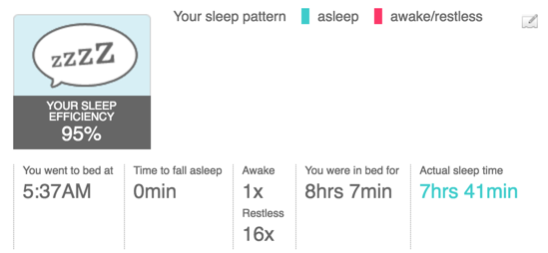

The time it takes for you to actually fall asleep is not incorporated into this calculation. The trackers work on a simple theory that movement equals wakefulness and prolonged lack of movement equals sleep.The tracker also takes into account the experimenter’s heart rate to decide if the person is asleep. For example, If you don't move all night, it is possible to get 100% sleep efficiency even if it takes you 20 minutes to fall asleep.The image below is a sample sleep efficiency generated by fitbit device .

**4)** **Choice of Factors, Levels, and Ranges:**

1. **Caffeine intake:** Since caffeine is a stimulant, most people use it after waking up in the morning or to remain alert during the day. As described on Healthline.com (2014),studies indicate that Caffeine is a central nervous system stimulant. The most noticeable effect is alertness. It can temporarily make you feel more awake and energetic. While it is important to note that caffeine cannot keep us from sleeping altogether, it can temporarily make us feel more alert by blocking sleep-inducing chemicals in the brain and increasing adrenaline production. In this experiment we will be able to verify this claim if Caffeine intake comes as a Significant Factor in our ANOVA table. Caffeine intake (measured in milligrams of caffeine present in item consumed) is done by the operator at a time frame of 1 hour before sleep. We are categorizing caffeine intake as

· High – 55mg and above

· Low – Below 10mg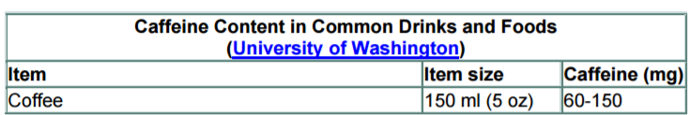

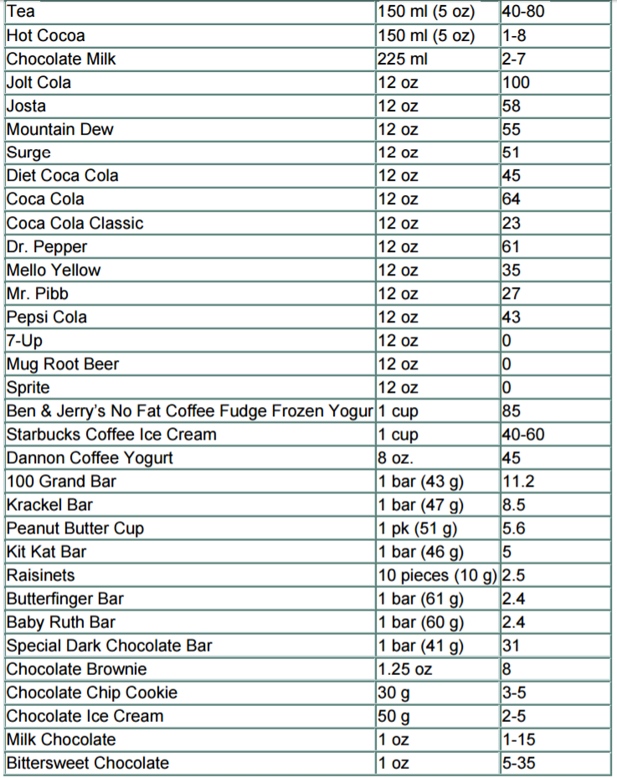

Source: <http://www.fda.gov/downloads/UCM200805.pdf>

1. **Calories Burnt:**

Physical activity might play an important role in the quality of sleep. If your body is tired, can it lead to better sleep? In this experiment, we will evaluate the answer to this question, by measuring the number of calories burnt calculated by fitness tracker and comparing it to the Sleep Efficiency. The Calories burnt is calculated by the fitness tracker based on the operator’s step count and heart rate throughout the day. This is categorized as:

· High – Calories Burnt Above 3000 Kcal

· Low – Calories Burnt Below 2400 Kcal

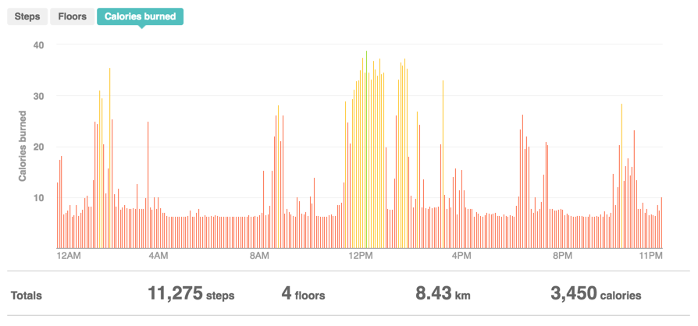

1. **Time difference between sleeps:**

It is ideal to have 7-9 hours of sleep every day. Considering a fixed schedule, this leaves a time gap of 15-17 hours between sleeps. For this experiment, we are evaluating the effect of time difference between two sleep cycle on the Sleep Efficiency. This is categorized as:

· High – 18 hours between sleep

· Low – 14 hours between sleep

1. **Nuisance Variables:**

* Operators: Different people tend to have different base sleep efficiency. It is also worth noting that different factors could affect people and their sleeping patterns differently. Since we are conducting the experiment with two operators, we will be blocking on Operators. Also, the two operators are of the same age and same ethnicity.
* Room Temperature - Room temperature could be a factor affecting sleep efficiency. However, this experiment was performed with room temperature held constant at 75F using a standard thermostat. Since we are not considering the effect of temperature on sleep, we have kept this as constant.

# **5)** **Experiment Design:**

For this experiment, we are measuring 1 response variable based on 3 factors with 2 levels each. This suggests the 2^3 factorial design to be an ideal choice. We will be performing the experiment in full factorial, 2 replicates using 2 blocks to block the effect of different operators.

This gives 16 runs of the experiment to be distributed equally to the two operators with each operator performing a full replicate of 8 runs.

**6) Performing the Experiment:**

This experiment was performed using FITBIT charge HR device to track sleep efficiency and calories burnt. Below is a description of how each factor was maintained during the experiment.

**Caffeine Intake:**

As mentioned in the description of factors, caffeine is a common product available in many food sources. The amount of caffeine intake is administered throughout the experiment.

* High: To ensure that same quantity of caffeine is administered to each operator, the source of caffeine, Starbucks Latte in Tall size which has 75 mg of Caffeine as per their website, is taken by both the operators one hour before their sleep cycle begins. In preparation for the experiment, no other known sources of high caffeine content such as Cola, Chocolates, coffee ice creams etc. were consumed at least 8 hours prior to the sleep cycle. For any other significant food source that contains caffeine, it is assumed that its effect will wear off within 6-8 hours of intake5. Hence, caffeine taken before 8 hrs of beginning of experiment should not have an effect on the sleep cycle.
* Low: No caffeine containing product was consumed during the day of experiment.

**Calories Burnt:**

For the two operators, the base level of calories depending on their weight and height were calculated by the software of the fitness tracker. For one operator, the base level is 2200 Cal, while for other operator it is 2100 Cal which is observed when they did not engage in exerting physical activity.

* High: We ensured that enough physical activity was done by the operators to take their calories burnt count over 3200 Cal. This was done by engaging them in physical activity such as sports.
* Low: The low level of calories is counted as less than 2400 Cal burnt. By not engaging in any exerting physical activity; this level was not crossed by both the operators.

Time Gap between Sleep:

Time gap between sleep is counted as the number of hours between waking up from sleep and going back to sleep for the next sleep cycle.

* High: High level of time gap is obtained by keeping the time difference between two sleep cycle as 18 hrs. We did not perform two experiments having High Level of Time Gap consecutively, to ensure this does not create a pile up of hours of sleeplessness.
* Low: Low Level of Time Gap was obtained by keeping the time difference between two sleep cycles as 14 hrs.

**7) Statistical Analysis**

After conducting the experiment, we analyzed all the collected data and its results on Minitab. The analysis of the experiment will be divided into two parts.

1) The initial model with all factors and check for Model Adequacy

2) Reduction of Model with only significant factors and interactions.

1. **The initial model with all factors:**

Analysis of Variance

Source                                       DF   Adj SS   Adj MS  F-Value  P-Value

Model                                         8  118.750  14.8438    20.78    0.000

  Blocks                                      1    4.000   4.0000     5.60    0.050

  Linear                                      3  104.500  34.8333    48.77    0.000

    Caffeine_Intake                           1   36.000  36.0000    50.40    0.000

    Calories_Burnt                            1   12.250  12.2500    17.15    0.004

    Time_Gap                                  1   56.250  56.2500    78.75    0.000

  2-Way Interactions                          3    9.250   3.0833     4.32    0.051

    Caffeine_Intake*Calories_Burnt            1    0.000   0.0000     0.00    1.000

    Caffeine_Intake*Time_Gap                  1    9.000   9.0000    12.60    0.009

    Calories_Burnt*Time_Gap                   1    0.250   0.2500     0.35    0.573

  3-Way Interactions                          1    1.000   1.0000     1.40    0.275

    Caffeine_Intake*Calories_Burnt*Time_Gap   1    1.000   1.0000     1.40    0.275

Error                                         7    5.000   0.7143

Total                                        15  123.750

Model Summary

       S    R-sq  R-sq(adj)  R-sq(pred)

0.845154  95.96%     91.34%      78.89%

The ANOVA table indicates that the Main factors are significant and only the 2-Way Interaction of Caffeine_Intake*Time_Gap is significant with a value of less than 0.05. The 3-Way Interaction is not significant.

Regression equation:

Regression Equation in Uncoded Units

Sleep Efficiency = 93.375 - 1.500 Caffeine_Intake + 0.875 Calories_Burnt + 1.875 Time_Gap

                   + 0.000 Caffeine_Intake*Calories_Burnt + 0.750 Caffeine_Intake*Time_Gap

                   - 0.125 Calories_Burnt*Time_Gap

                   + 0.250 Caffeine_Intake*Calories_Burnt*Time_Gap

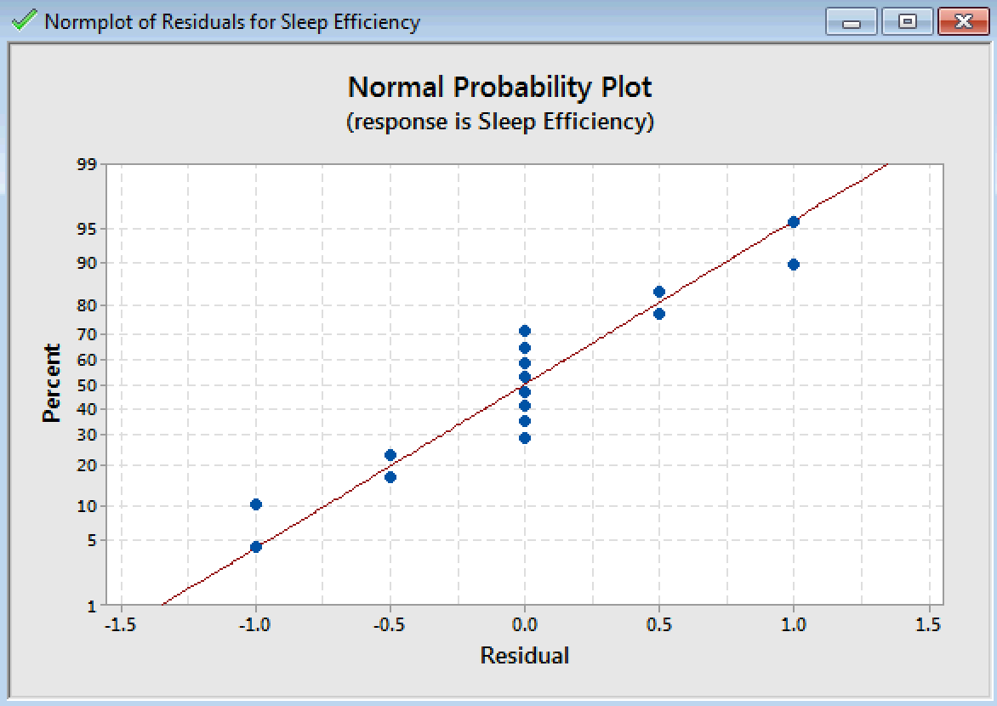

Per Normal Probability Plot, there are some deviations from Normality, which signify that normality assumption is not met.

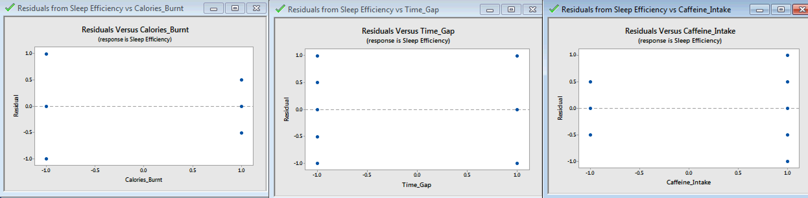

The plot of Residuals versus various Factors also reveals difference in variation, hence model is inadequate, and requires Transformation.

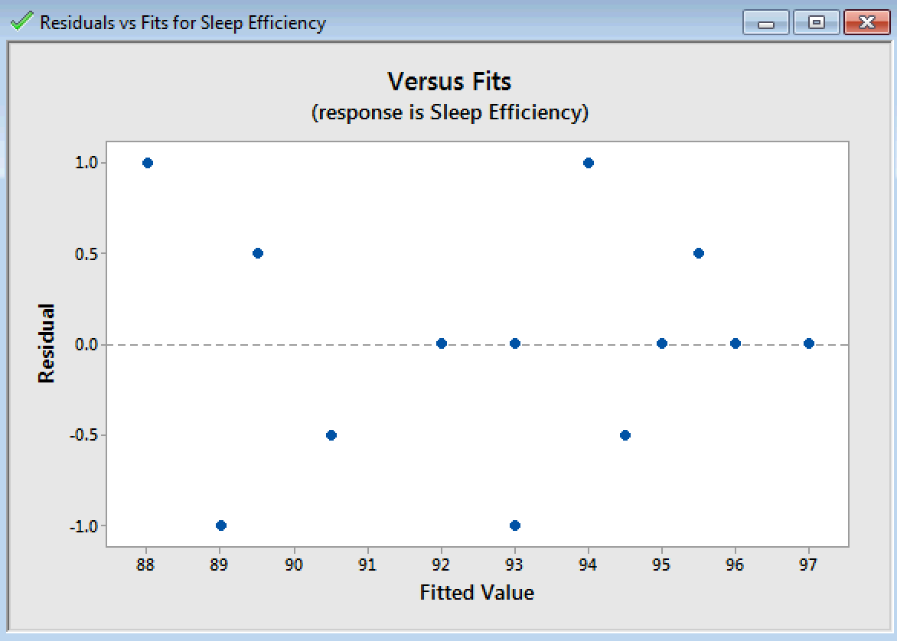

The Residual versus Fits plot also indicates some pattern and confirms the need for Transformation.

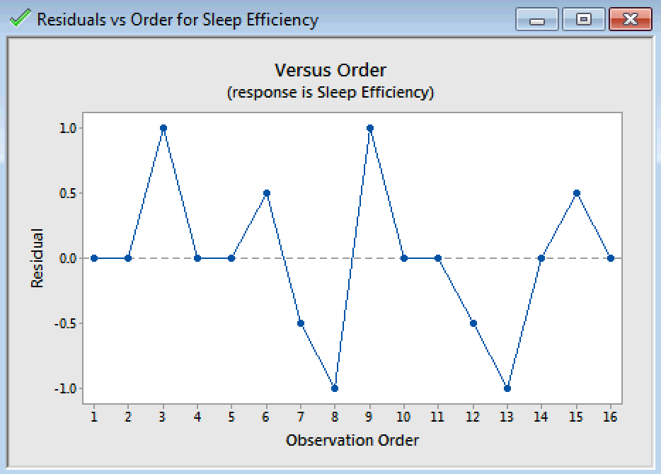

The Residuals versus Order plot shows Randomness.

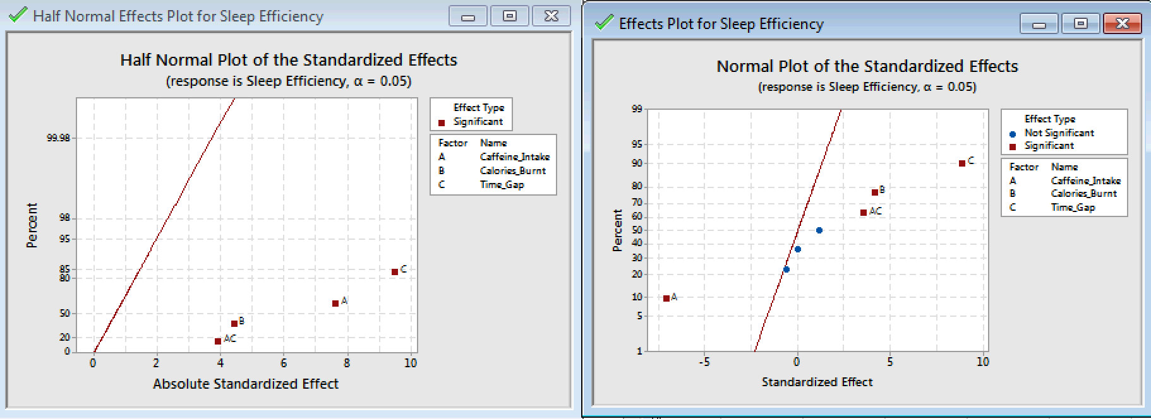

The Normal Plot of Standardized Effects reveals that all Main Effects Caffeine_Intake, Calories_Burnt and Time_Gap are significant, while interaction between Caffeine_Intake and Calories_Burnt is also significant. The Half-Normal plot indicates that the positive effect of Time_Gap is higher than the negative effect of Caffeine_Intake. Also, an interesting observation is that the interaction of Caffeine_Intake* Time_Gap has a positive effect on Sleep_Efficiency.

Since the Residuals versus Factors were showing difference in variation, we have **transformed** the model using **λ = -1** as follows:

ANOVA:

Analysis of Variance for Transformed Response

Source                                       DF    Adj SS    Adj MS  F-Value  P-Value

Model                                         8  0.000056  0.000007    20.87    0.000

  Blocks                                      1  0.000002  0.000002     5.27    0.055

  Linear                                      3  0.000049  0.000016    48.86    0.000

    Caffeine_Intake                           1  0.000017  0.000017    50.83    0.000

    Calories_Burnt                            1  0.000006  0.000006    16.98    0.004

    Time_Gap                                  1  0.000026  0.000026    78.76    0.000

  2-Way Interactions                          3  0.000005  0.000002     4.61    0.044

    Caffeine_Intake*Calories_Burnt            1  0.000000  0.000000     0.00    0.951

    Caffeine_Intake*Time_Gap                  1  0.000004  0.000004    13.39    0.008

    Calories_Burnt*Time_Gap                   1  0.000000  0.000000     0.42    0.536

  3-Way Interactions                          1  0.000000  0.000000     1.27    0.296

    Caffeine_Intake*Calories_Burnt*Time_Gap   1  0.000000  0.000000     1.27    0.296

Error                                         7  0.000002  0.000000

Total                                        15  0.000058

Model Summary for Transformed Response

        S    R-sq  R-sq(adj)  R-sq(pred)

0.0005795  95.98%     91.38%      78.97%

Regression Equation:

Regression Equation in Uncoded Units

-Sleep Efficiency^-0.1 = -0.635329 - 0.001033 Caffeine_Intake + 0.000597 Calories_Burnt

                         + 0.001286 Time_Gap + 0.000009 Caffeine_Intake*Calories_Burnt

                         + 0.000530 Caffeine_Intake*Time_Gap

                         - 0.000094 Calories_Burnt*Time_Gap

                         + 0.000164 Caffeine_Intake*Calories_Burnt*Time_Gap

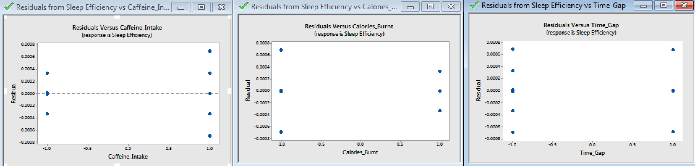

The Residual versus various Factors still show some difference in variance.

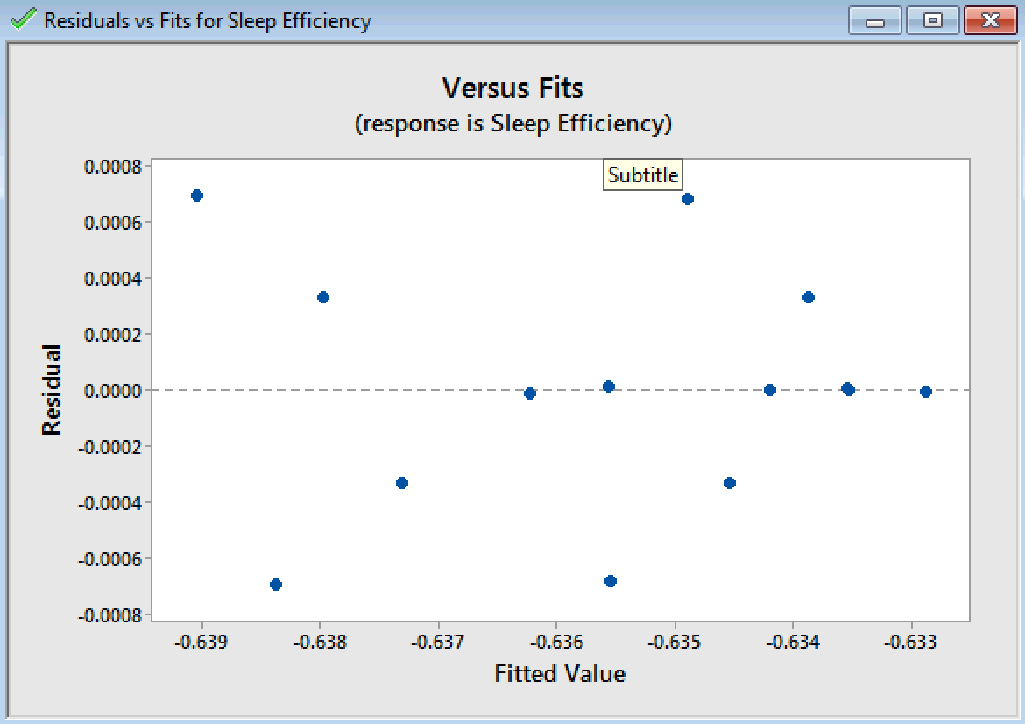

The Residual versus Fits plot also shows some pattern, indicating that the transformation did not have much effect in improving the variance.

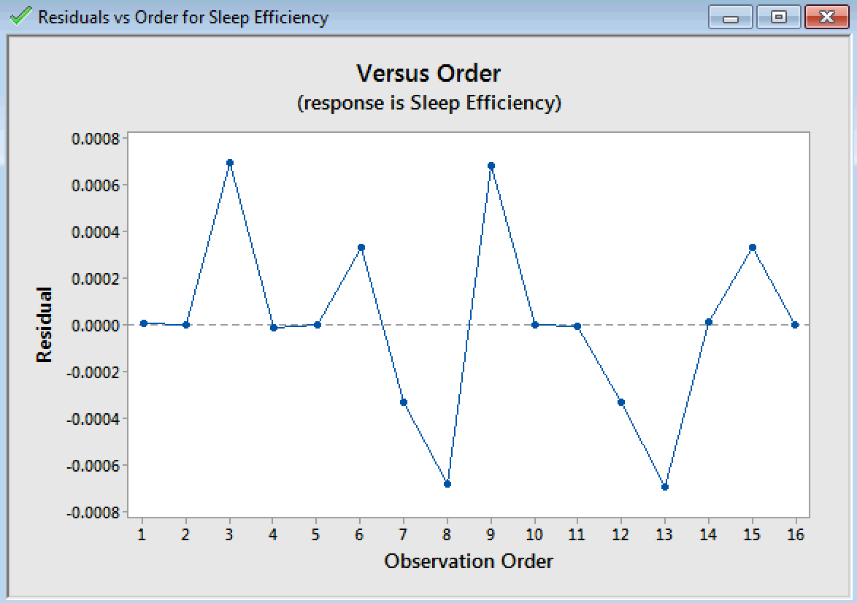

The Residual versus Order plot shows Randomness.

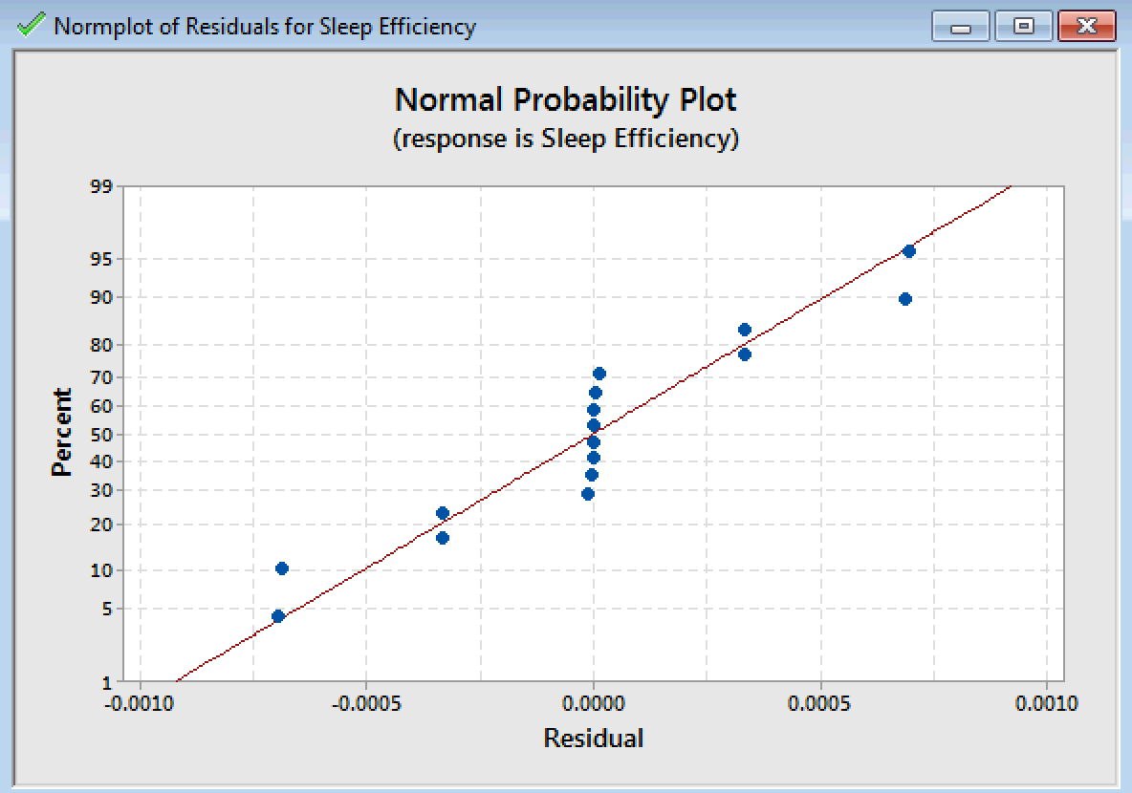  
The Normal probability plot has improved slightly as compared to the non-transformed model.



The Half Normal and Normal Plot of Standardized Effects are similar to the non-transformed model.

1. **Model Reduction**

We can reduce the model by removing insignificant interactions, which includes interaction effects of Caffeine_Intake*Calorie_Burnt, Time_Gap*Calorie_Burnt and 3-Way interaction of Caffeine_Intake*Calories_Burnt*Time_Gap.

ANOVA:

Box-Cox transformation  λ = -0.1

Analysis of Variance for Transformed Response

Source                        DF    Adj SS    Adj MS  F-Value  P-Value

Model                          5  0.000055  0.000011    37.98    0.000

  Blocks                       1  0.000002  0.000002     6.06    0.034

  Linear                       3  0.000049  0.000016    56.15    0.000

    Caffeine_Intake            1  0.000017  0.000017    58.42    0.000

    Calories_Burnt             1  0.000006  0.000006    19.51    0.001

    Time_Gap                   1  0.000026  0.000026    90.52    0.000

  2-Way Interactions           1  0.000004  0.000004    15.39    0.003

    Caffeine_Intake*Time_Gap   1  0.000004  0.000004    15.39    0.003

Error                         10  0.000003  0.000000

Total                         15  0.000058

Model Summary for Transformed Response

        S    R-sq  R-sq(adj)  R-sq(pred)

0.0005405  95.00%     92.50%      87.19%

Regression Equation:

Regression Equation in Uncoded Units

-Sleep Efficiency^-0.1 = -0.635329 - 0.001033 Caffeine_Intake + 0.000597 Calories_Burnt

                         + 0.001286 Time_Gap + 0.000530 Caffeine_Intake*Time_Gap

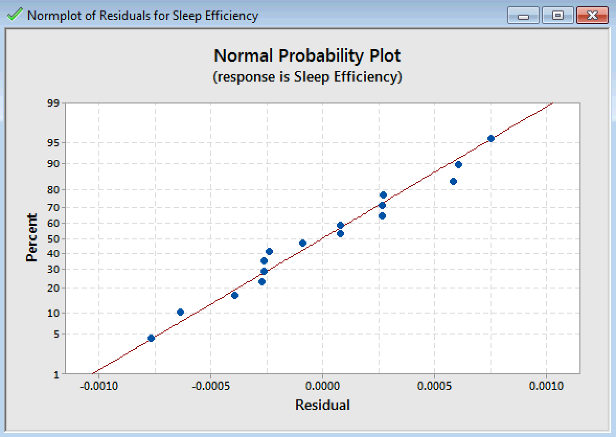

Reducing the model to only include the significant effects has improved the Normal Probability Plot considerably. We can say that the Residuals are Normally distributed with exception of a few points.

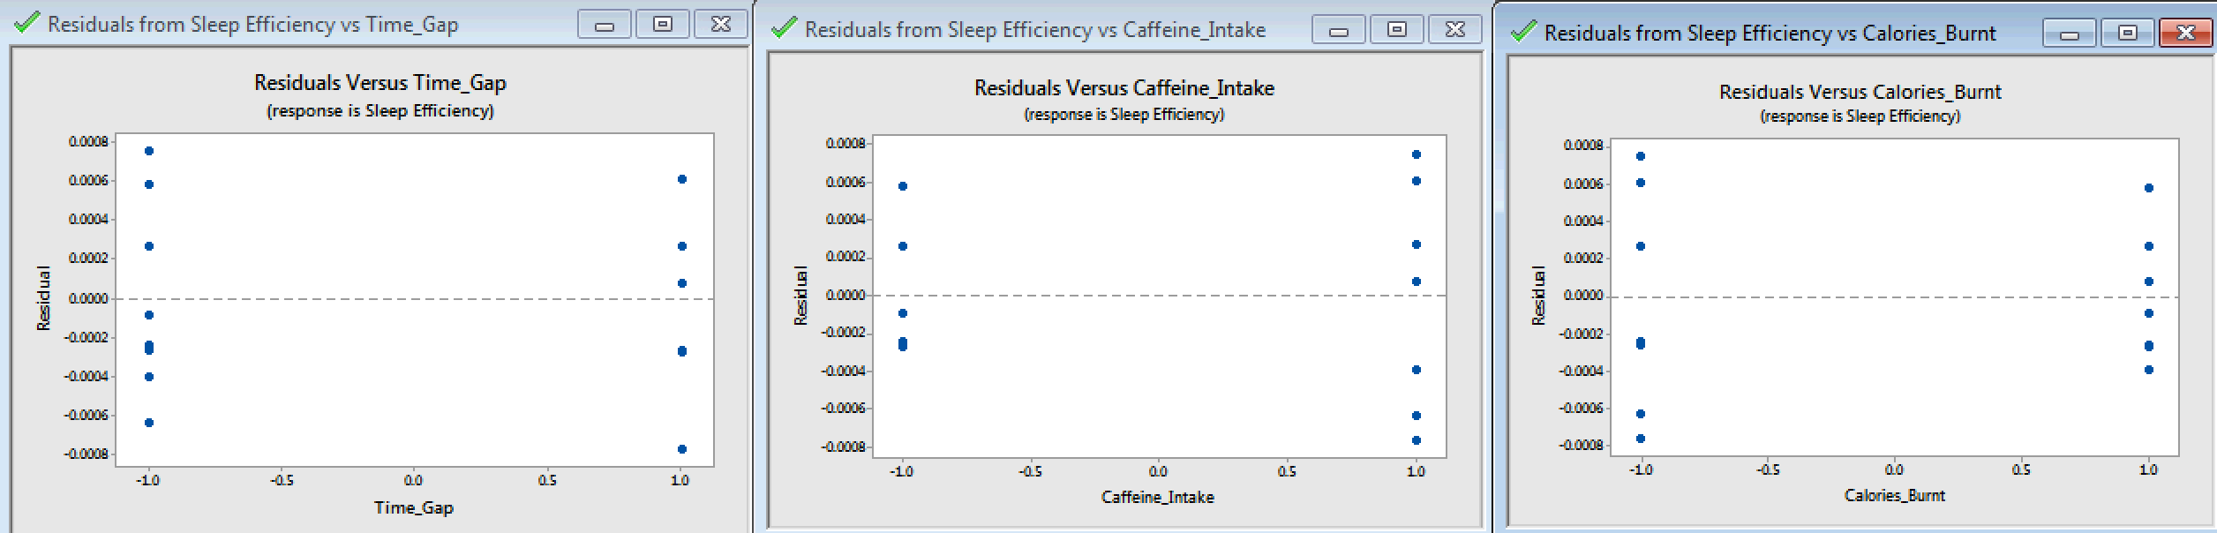

The Residuals versus Main Factors plots also show reduced difference in variance.

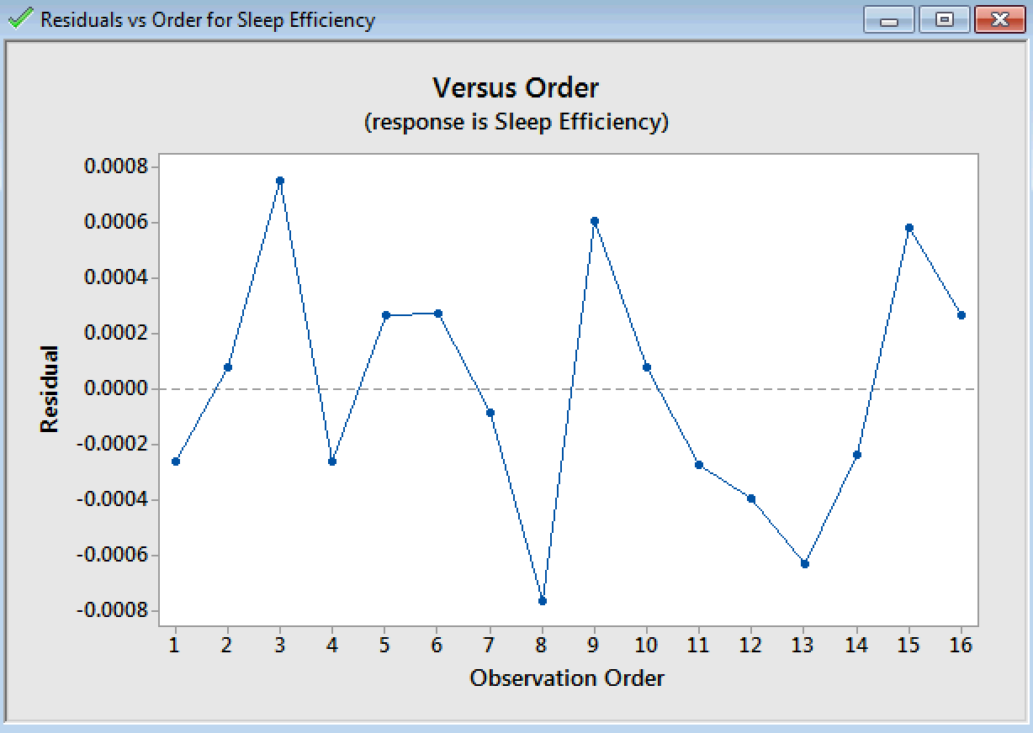

The Residuals versus Order plot is random.

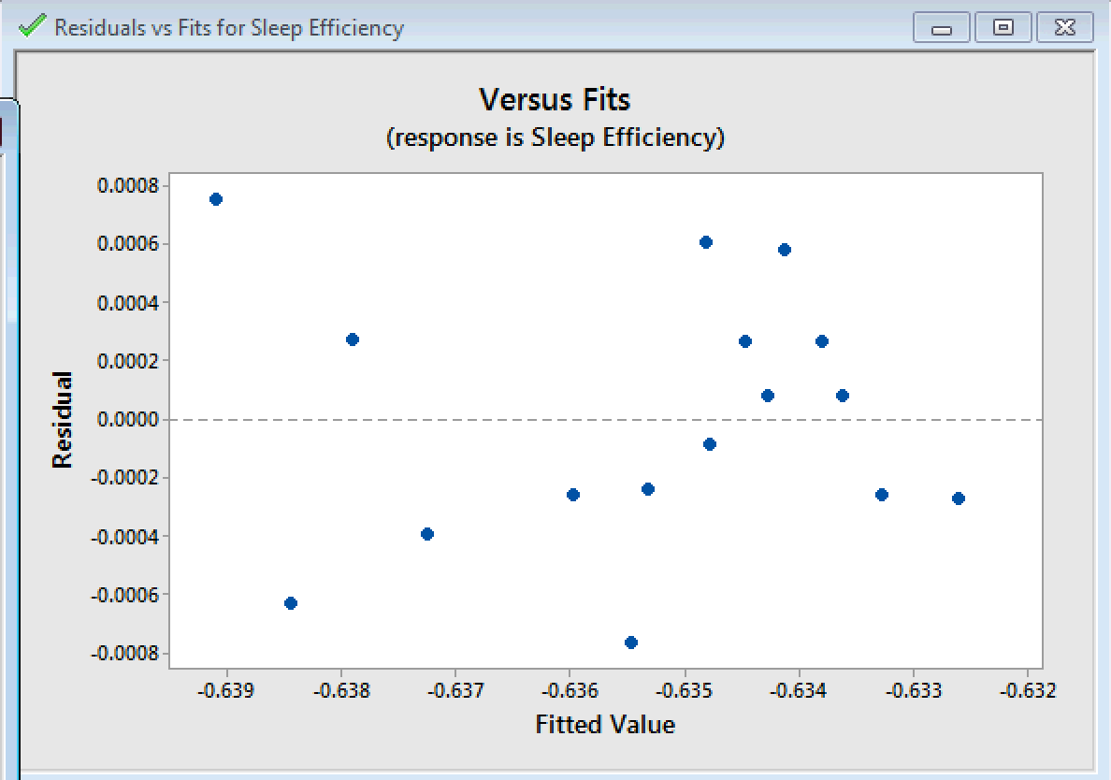

The Residuals versus Fits plot also shows improved randomness as compared to previous models.

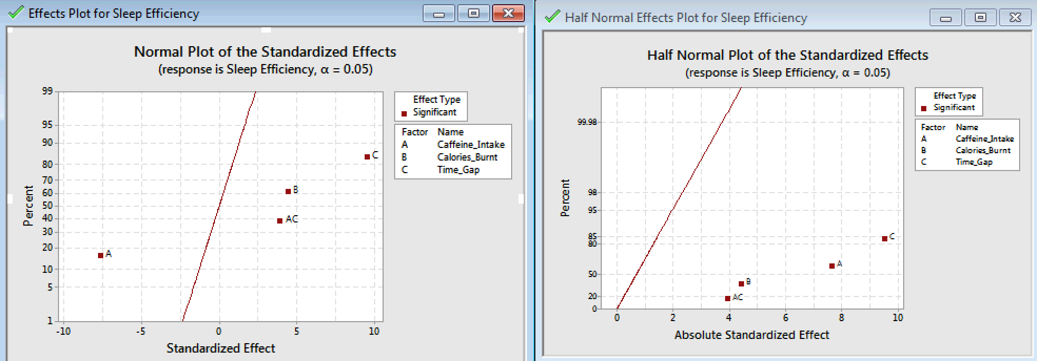

The Normal and Half-Normal Plots of Standardized Effects did not change in the terms that were significant.

Main Effects Plot and Interaction Plots:

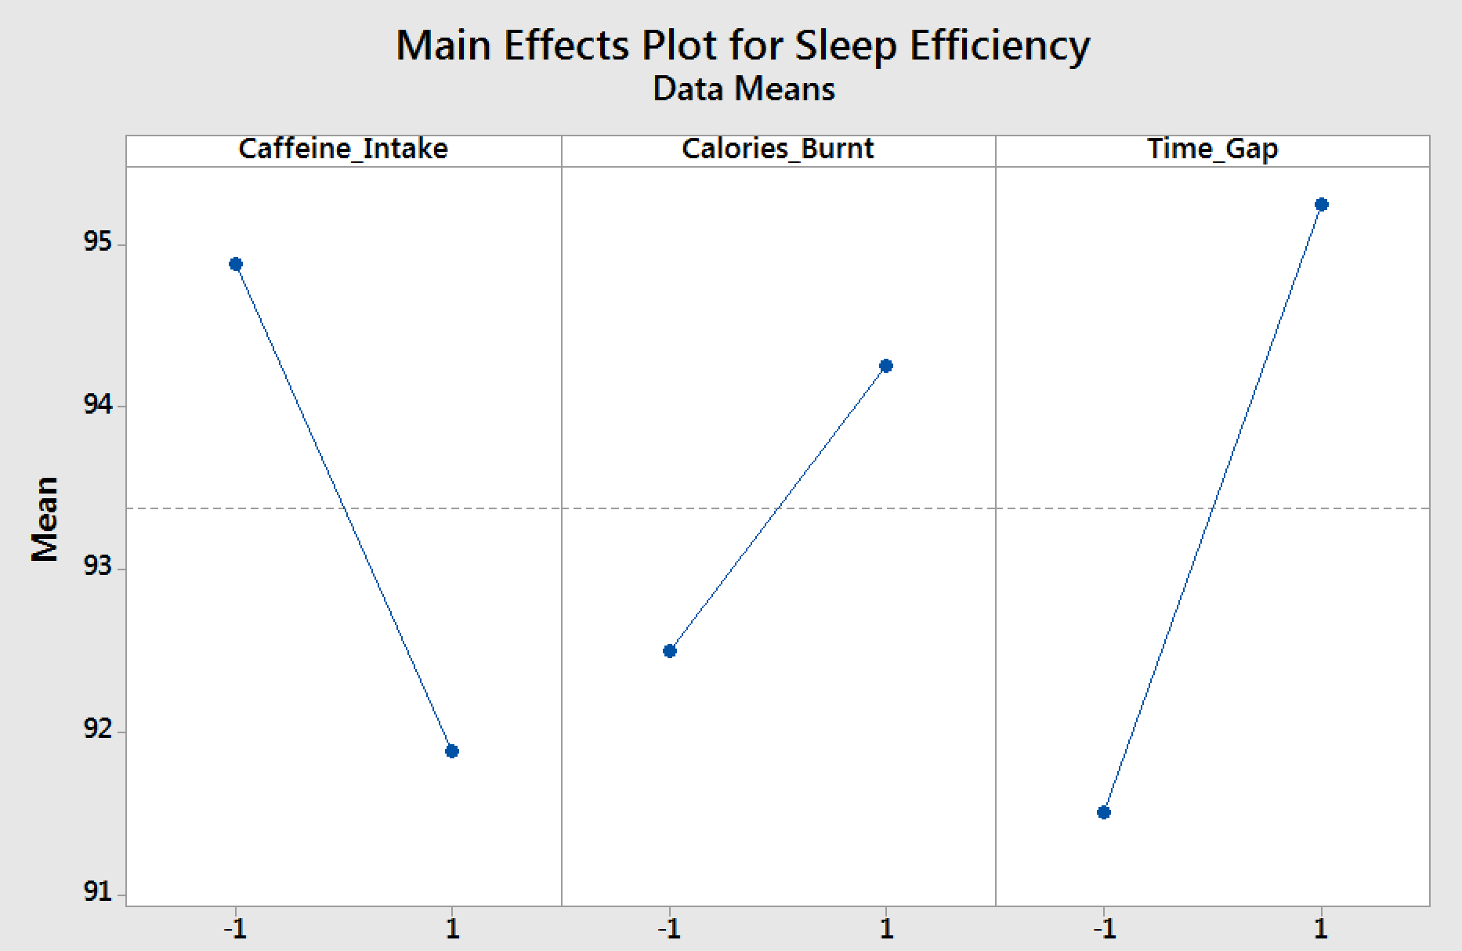

The Main Effects plot indicates that Higher Caffeine_Intake has a negative effect, while Calories_Burnt has a moderate positive effect on Sleep_Efficiency. It can be seen that Time_Gap has a large positive effect on Sleep_Efficiency which is consistent with the observation made in the Half-Normal plot.

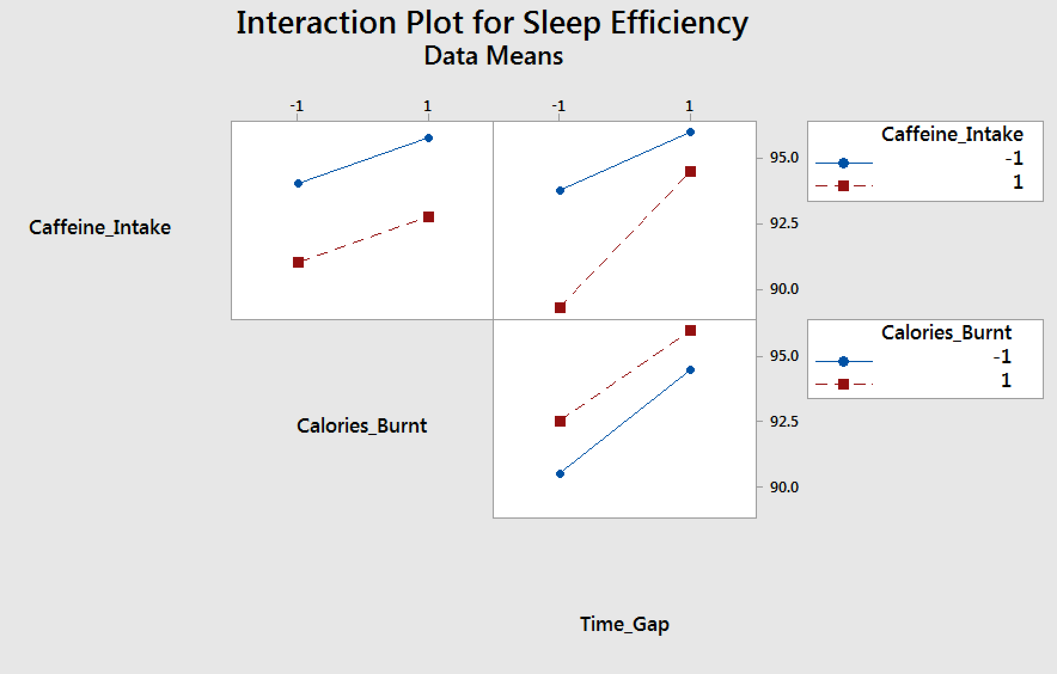

The interaction plot shows that the Calories_Burnt and Caffeine_Intake has parallel lines indicating no significant interaction between the two factors. The response variable will be higher at high level of Time_Gap and low level of Caffeine_Intake. The response variable will be low at low level of Time_Gap and high level of Caffeine_Intake.

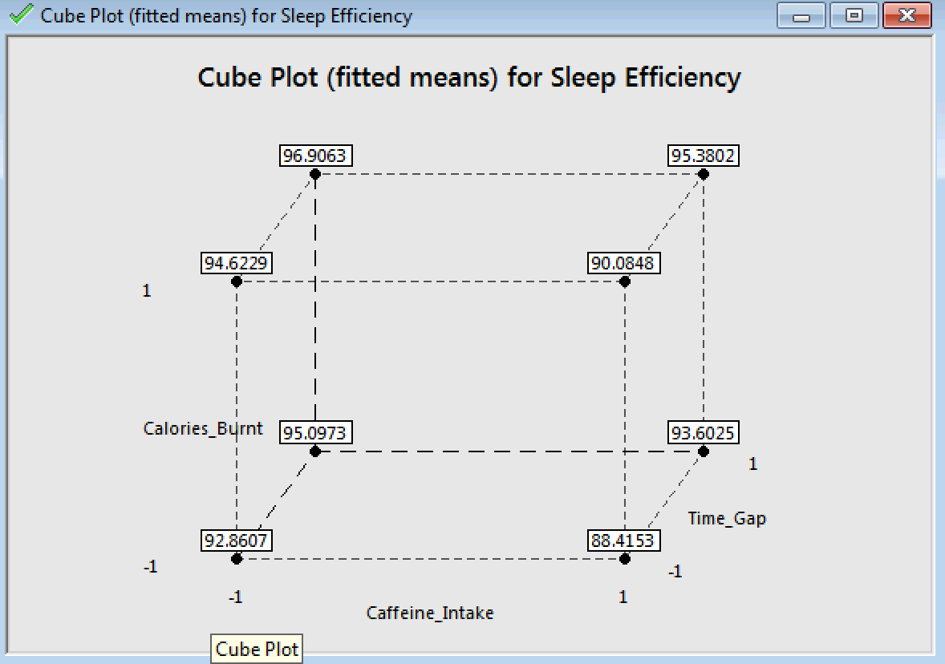

The Cube Plot for Sleep Efficiency indicates that the highest value of Sleep_Efficiency will be obtained at low level of Caffeine_Intake, high level of Calories_Burnt and high level of Time_Gap, while the least value of Sleep_Efficiency will be obtained for low levels of Calories_Burnt and Time_Gap and high level of Caffeine_Intake.

**8) Conclusion**

The intent of the designed experiment was to determine which of the factors affect the efficiency of sleep. The experiment results suggest us that -

* Caffeine intake has a negative effect on Sleep Efficiency
* Calorie burnt has a positive effect on Sleep Efficiency
* Time gap between sleep has a positive effect on Sleep Efficiency
* Caffeine intake and Time gap together has a positive effect on Sleep Efficiency indicating that the Time gap has a stronger influence than Caffeine intake on Sleep Efficiency

**9) Recommendations**

To make improvements in future studies, we can take more directions into consideration.

* The number of replicates could be increased by increasing the number of operators and performing the experiment for a prolonged period to objectively analyze the impact of factors on sleep efficiency. It could also nullify certain nuisance variables like psychological state of operators before sleep.

**10) References:**

1) <https://help.fitbit.com/articles/en_US/Help_article/1314>

2) <https://sleepfoundation.org/sleep-topics/caffeine-and-sleep>

3) <http://www.healthline.com/health/caffeine-effects-on-body>

4) <http://www.fda.gov/downloads/UCM200805.pdf>

5) <http://www.caffeineinformer.com/caffeine-metabolism>